Day Trip to Debre Ziet

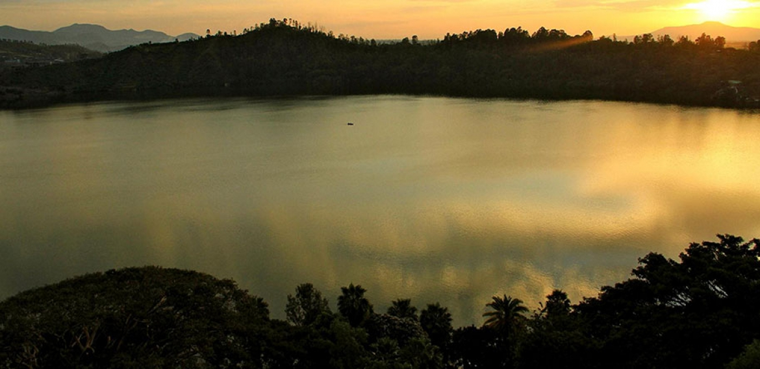
Duration-Full days
Mode of transportation: - Car

Debre Ziet
You will pick up from your hotel or airport and drive to Debre Ziet. Located around 60 km from Addis Ababa, Debre Zeyit is the most popular resort town near Addis Ababa. It is famed for its beautiful weather, scenic landscapes and five crater lakes. It has several resorts with different types of amenities to suit your needs. On this tour you will some crater lakes, which are excellent for picture taking, birdwatching or short trekking; in between visiting the crater lakes, you have the option of stopping by a local coffee shop for a traditional Ethiopian coffee ceremony. After you are finished exploring the crater lakes, you will go to a surprisingly authentic local restaurant for a traditional Ethiopian lunch experience; after lunch, you will be taken to a crater-by resort known for its true representation of Ethiopia, from the design of its facilities to its customer service. Here, you will enjoy your entire afternoon engaging in water and spa activities, culminating your day in a massage experience known by many to be the best in Ethiopia. After afternoon, you will drive back to Addis Ababa and dropped off at your preferred location.

